Maximo Antigua

CST 2309 Lab 3.1

Refer to Tutorial 2: Create a Website for a Fitness Club

1. Complete Session 2.1 from pages HTML 86 to HTML 106

Add a screenshot of the **tss_home.html** file displayed in a browser after completing Step 3 on page HTML 104. Include the address bar in the screenshot. See Figure 2-11 for reference.

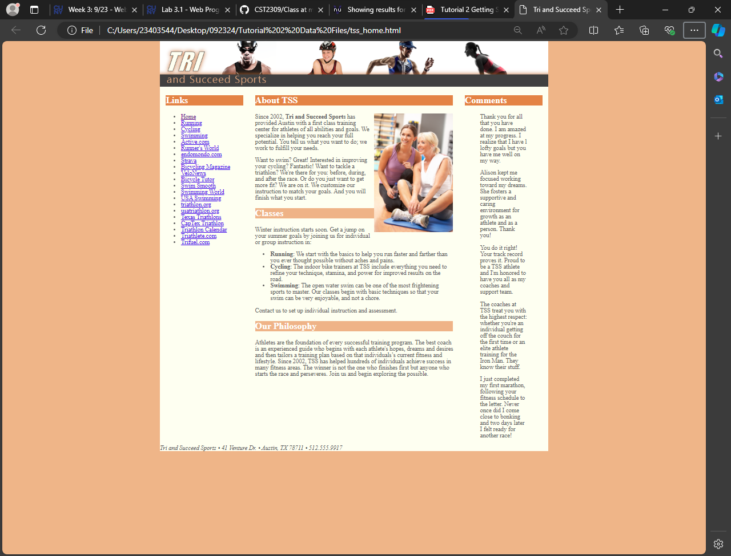

1. Complete the Session 2.1 Quick Check in Blackboard